EVDashboard Installation Instructions

Notice
This software is made up from various SQL and ADODB vbscripts which have been incorporated into the .ASP pages of the dashboard. Whilst every effort has been made to ensure high quality code you should test the dashboard thoroughly before putting it into your production environment.
It is highly recommended you install this into your test environment to verify functionality before installing into your production environment.
At the end of the day there is only one person who holds the responsibility for the integrity of your IT infrastructure; you. The authors of this software will not be held responsible for any adverse effects from the use of this software. You use at your own risk.

Table of Contents
Recommended Configuration 3
Pre-requisites 3
EVDashboard installation 3
Extract files 3
Setup XML file 3
Configure IIS 4
How to install IIS 4
Enabling Active Server Pages and ASP.NET 4
Configuring ASP.NET on 64-bit versions of Windows Server 2003 5
Setting Permissions on EVDashboard Directory 5
Configure the Database 7
Create Database Structure 7
Create Tables in the Database Structure 7
Create user accounts 7
Allow Remote Connections 10
Application configuration 11
Configure Scheduled Tasks 12
Verifying your config 13
Troubeshooting 13

Recommended Configuration
Microsoft SQL Server 2005 or better
Microsoft Internet Information Server (IIS)

Pre-requisites
For installing EVDashboard you will need:
- Download the latest build from https://sourceforge.net/projects/evdashboard/.
- A SQL server database to store the information generated by the ./scripts/documentation/EVDashboard_Data_Collector.vbs.
- Remote access to this database (via port 1433).
- An IIS, or other ASP enabled web server.
- Some knowledge of SQL databases or a dba, this will help with setting up the database and database tables.
- Remote SQL access to each Enterprise Vault database (via port 1433).
- Some knowledge of VBScript / ASP useful, but not essential.

EVDashboard installation
EVDashboard is a large collection of Active Server Pages (ASP) that reaches into your Enterprise Vault Architecture and collects valuable data and displays it on an Internet Information Server (IIS) or other ASP enabled web server. For the purposes of this document we will assume that you are using a Microsoft SQL server and a Microsoft IIS web server. We recommend that you use your Enterprise Vault Application server as it already has IIS configured properly.

Extract files
Extract the files to the document root for your web server. On an IIS server this is typically located at c:\inetpub\wwwroot. Make sure the completed path looks like this:
c:\inetpub\wwwroot\EVDashboard

Setup XML file
Locate the following file c:\inetpub\wwwroot\EVDashboard\config\config.new.install.xml and rename it to config.xml.
Check the permissions on the config.xml file by right clicking on the file and bringing up the properties. On the security properties of this file add Internet Guest Account, so this file can be written to within the EVDashboard ASP pages. (See Graphic 1.1)
Graphic 1.1
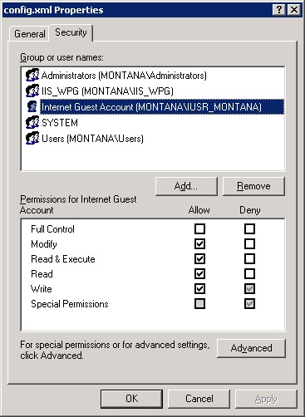

Configure IIS
If you are installing EVDashboard on your Enterprise Vault Server proceed to Setting Permissions on EVDashboard Directory

How to install IIS
- Click Start, point to Control Panel, and then click Add or Remove Programs.
- In Add or Remove Programs, click Add/Remove Windows Components.
- In the Windows Components Wizard, under Components, select Application Server.
- Click Next.
- After the wizard completes the installation, click Finish.
Note: Selecting Application Server performs a default installation of Internet Information Services (IIS) and includes components that are not necessary for Certificate Services. In most cases, this installation is acceptable for an isolated test environment. However, if you plan to connect your test environment to your production network, consult your organization's security policy to determine which components to install.

Enabling Active Server Pages and ASP.NET
- On Windows Server, you need to enable Active Server Pages and ASP.NET manually.
- To enable Active Server Pages and ASP.NET on Windows Server 2003
- Open Add/Remove Programs and click Add/Remove Windows Components.
- To install required components and enable Active Server Pages, select Application Server and click Details.
- Ensure that ASP.NET is selected.
- Select Internet Information Services (IIS) and click Details.
- Scroll down to World Wide Web Service.
- Click World Wide Web Service and then click Details.
- Select Active Server Pages and click OK.
- Click OK to close the dialog boxes until you get back to the Windows component list.
- Click Next to install the additional components.
- Click Finish.
- To check that Active Server Page scripts can run, start the IIS Manager by clicking Start > Programs > Administrative Tools > IIS Manager.
- Click Web Service Extensions.
- Check that “Active Server Pages are Allowed”.

Configuring ASP.NET on 64-bit versions of Windows Server 2003
If you are installing Enterprise Vault on a 64-bit version of Windows Server 2003, you need to switch to the 32-bit version of ASP.NET 2.0.
To do this, see the following article in the Microsoft Knowledge Base:
http://support.microsoft.com/?kbid=894435

Setting Permissions on EVDashboard Directory
- To check that Active Server Page scripts can run, start the IIS Manager by clicking Start > Programs > Administrative Tools > IIS Manager.
- Expand you local computer
- Expand Web Sites
- Expand “Default Web Site” (See Graphic 1.2)
- Right Click EVDashboard and Select Properties
- Click on the directory security tab.
- Click edit under Authentication and Access Control. (See Graphic 1.3)
- Uncheck enable anonymous access.
- Check basic authentication. – Passwords are sent in clear text unless you have a SSL certificate installed. You may want to also check “Integrated Windows Authentication” which will allow pass-thru if you are accessing the site from domain authenticated system.
- Click on the documents tab - remove all and add index.asp (See Graphic 1.4)
Graphic 1.2
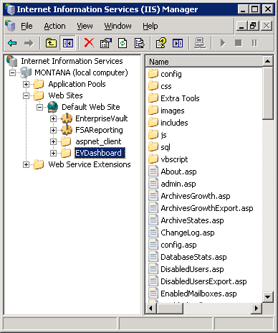
Graphic 1.3
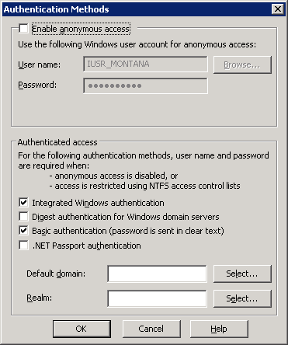
Graphic 1.4
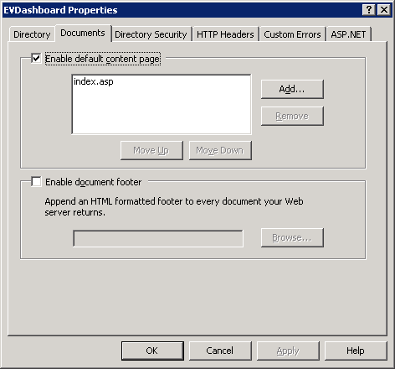

Configure the Database
On your sql server you will need to execute the following sql files to create the framework for the EVDashboard data. You can either open these files and cut and paste the code into your sql database or you can open these files from the sql database itself.

Create Database Structure
Use the sql code in C:\Inetpub\wwwroot\EVDashboard\sql\EVDashboard Database Creation \CreateEVDashboardDatabase.sql to create the EVDashboard database on your database server.

Create Tables in the Database Structure
Use the sql code in C:\Inetpub\wwwroot\EVDashboard\sql\EVDashboard Database Creation\CreateTables.sql to create the tables within the EVDashboard database on your database server.

Create user accounts
You will want to create a sql user account that has read only access to your Enterprise Vault DB structure. You will also want to create a separate user that has read/write access to your EVDashboard DB structure.
On your SQL server you need to open up the SQL Server Manager Studio by clicking Start > All Programs > Microsoft SQL Server > SQL Server Management Studio
You will need to create a new sql user account by right clicking on Logins and creating a new user account (See Graphic 1.5).
Graphic 1.5
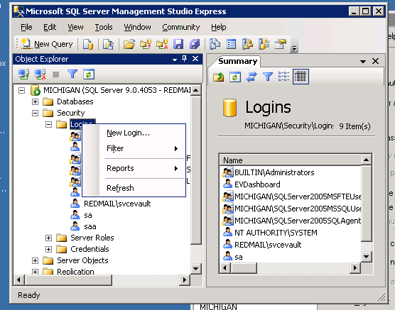
Create a new user called EVRO_User with the following settings (See Graphic 1.6):
- SQL Server Authentication
- Enforce password policy
- Default Database – Set to your Archiving Database
Graphic 1.6
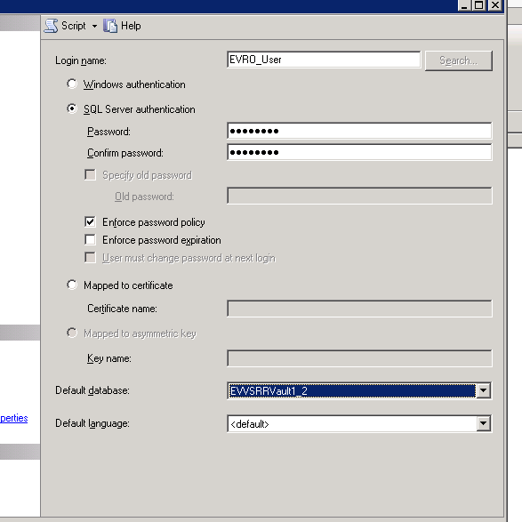
You will also need to set the “User Mapping” portion to grant read rights to your entire Enterprise Vault DB’s but make sure to exclude your EVDashboard DB. You do this by granting the db_datareader Database Role to this user. (See Graphic 1.7)
Graphic 1.7
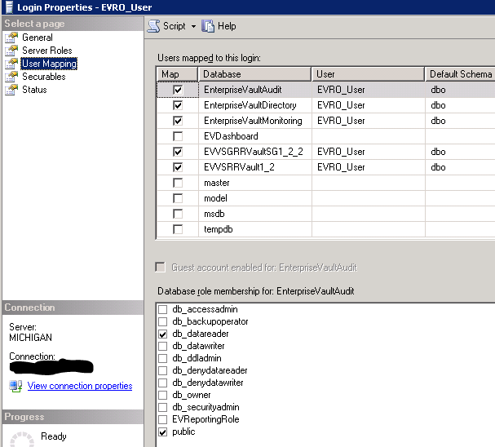
Create an additional user called EVD_User with the following settings (See Graphic 1.8):
- SQL Server Authentication
- Enforce password policy
- Default Database – Set to your EVDashboard Database
Graphic 1.8
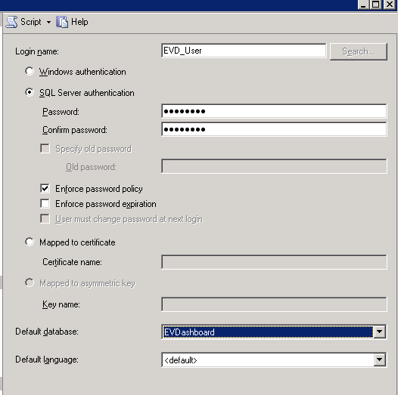
You will also need to set the “User Mapping” portion to grant full owner rights to your databases. (See Graphic 1.9)
Graphic 1.9
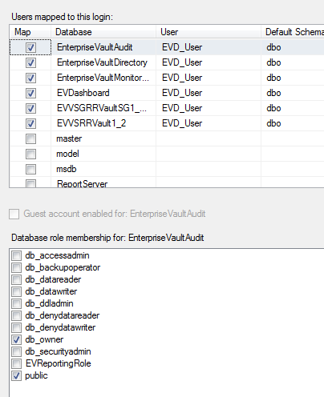

Allow Remote Connections
On your sql server you will need to start the SQL Server Surface Area Configuration by clicking Start > All Programs > Microsoft SQL Server > Configuration Tools > SQL Server Surface Area Configuration
This will open up a window and you should select “Surface Area Configuration for Services and Connections”
Confirm that you have enabled Remote Connections (See Graphic 1.10)
Graphic 1.10
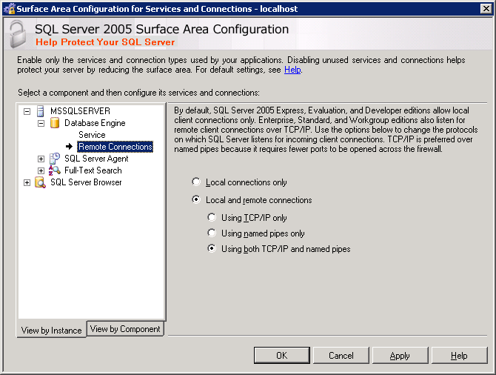
Verify that port 1433 is listening by performing the following command on your SQL server. Start > Run > CMD
Once this window opens run the following command:
Netstat –an | find “1433”
You should see something similar to this:

Application configuration
You should now be able to access your EVDashboard from the following URL http(s)://{Your_IIS_Server}/evdashboard
For example: http://mgmtsrv01/evdashboard.
You are now taken to the configure EVDashboard page. Here you can set your global options and define your EV infrastructure.
The first section pertains to how to access your Enterprise Vault DB structure. Use the users you previously created. (See Graphic 1.11)
Graphic 1.11
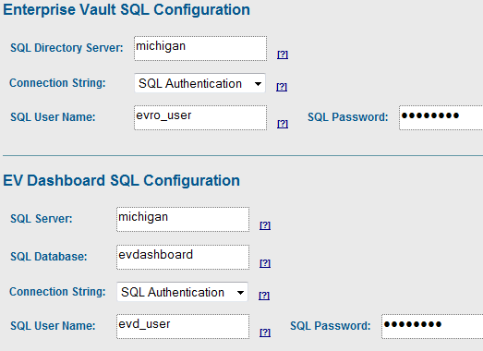
The lower section is used to gain access to your EV Infrastructure. You will need to fill in the fields as follows:
- DNS Alias – This can be found by opening your Evault Admin Console and looking under Enterprise Vault Servers
- Server Real Name – This is the hostname of your Evault Server
- Datacenter – This is for informational purposes only
- Database – This should be set to the name of either your file or email archiving database. This is not the Vault Store group database but the actual Vault Database
- DB Server - This is the name of your SQL server
- Role – This is either Email Archiving or File Archiving and is relevant to what you chose for the Database
- MSMQ Path – This is the physical path that you setup for your message queue. Ex.V:\msmq\
- Trigger File Path – This is the path to your trigger file
You should now be able to go to the home page and see table structure. There will be no data yet as the collection script has not been run.

Configure Scheduled Tasks
On your EVDashboard server you will need to configure a scheduled task to run the collection script daily so that it will populate the EVDashboard database.
- You can do this by clicking Start > All Programs > Accessories > System Tools > Scheduled Tasks
- Add a scheduled task
- Click Browse
- Select the following file C:\Inetpub\wwwroot\EVDashboard\vbscript\ EVDashboard_Data_Collector.cmd
- Perform this task Daily
- Schedule it to run at 6AM – If this script is set to run after 8:30 AM it will not collect full system data, so make sure it is set to run sometime between midnight and 8:30AM. Make sure to give it enough time to complete.
- You will need to supply this task with a user account that has the ability to run commands on that machine. A common choice is the service account you used to setup your Enterprise Vault infrastructure.
Your EVDashboard environment should be fully functional now! Sit back and enjoy the data.

Verifying your config
There are a couple of ways to verify that you have configured your EVDashboard environment correctly.
- Health Checks -> 'EV Disk Usage Information'
- Health Checks -> 'EV Services'
- Health Checks -> 'MSMQs - Message Counts'

Troubeshooting
Most problems seem to be related to the inital configuration of the database connectivity for EVDashboard, or more precisely VBScript ADODB to connect to your designated SQL database and your Enterprise Vault SQL database. Try the following:
From your database server run netstat -a | find "1433". You are looking to confirm there is a listening connection for port 1433.
Confirm no firewalls (software or hardware) are blocking communication channels for port 1433 on your servers.
Try the test database connectivity page within EVDashboard. This can provide some insight, including errors on any potential problems.
Beyond this post your questions with error messages on the forums at https://sourceforge.net/projects/evdashboard/.

